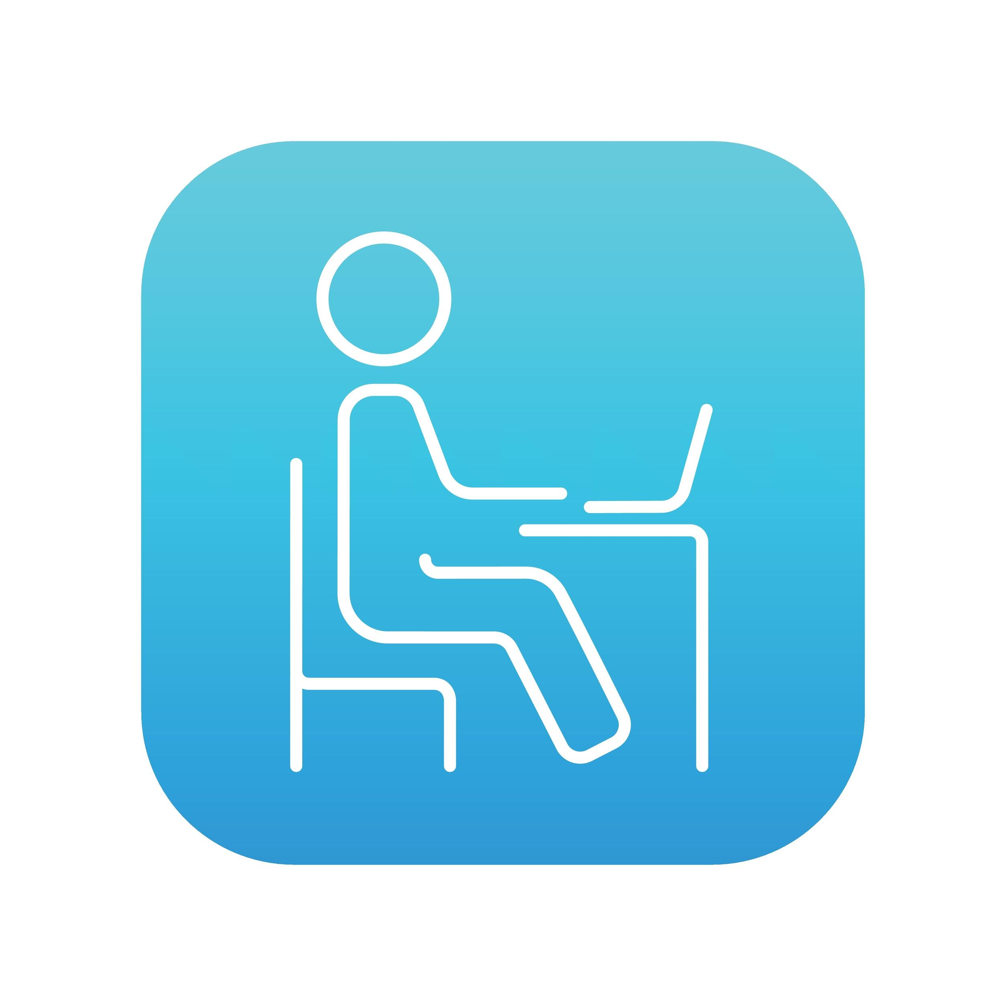
1:1 Program

Student and Parent/Guardian Handbook

\Safe, Smart and Happy!

Table of Contents
Sheridan 1:1 Program Info 2
Repairing or Replacing Student Chromebooks and iPads 2
End of School Year / Changing Schools 3
Protecting and Storing Chromebooks and iPads 3
Taking Care of Chromebooks and iPads 4
Chromebook Use 4
Internet Connectivity 5
Managing Chromebook Files & Saving Work 6
Gmail for Students 6
Software on Chromebooks 7
Chromebook and iPad Device Troubleshooting and Help Resources 7
Copyright & Plagiarism 8
Internet and Social Media 8
Digital Citizenship 8
Cyber-Bullying 9
Internet Safety 10
Internet Privacy & Security 10
Internet Safety Resources 11
Parent/Guardian Guidance 11
Signature Agreements 12
Take-Home Mobile Device Responsibility Agreement 12
Sheridan 1:1 Program Pledge 13

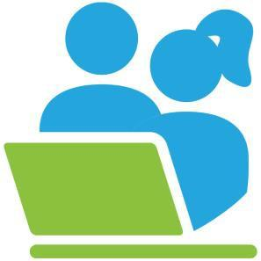
Sheridan 1:1 Program Info

Technology is a powerful tool to engage and empower students. The 2020 COVID-19 pandemic has accelerated Sheridan School District’s plans to increase technology use in supporting teaching and learning. In response to needing to provide continuity of education to our Sheridan students in a remote learning environment we have made it a priority to move to a one-to-one (1:1) computer device program for all students (ECE-12) in Sheridan in the 2020-21 school year. Through this new program, students will be issued Chromebook laptop computers (grades 1-12) and iPad tablets (ECE-K) for use both at school and at home.

Sheridan School District (SSD) designed our program in partnership with iLearn Collaborative that has over 10 years of experience implementing 1:1 programs in districts throughout the state of CO. This partnership will further ensure the program’s success, as school and district staff will receive additional professional development and technical support.
The Chromebooks and iPads issued to Sheridan students belong to SSD 2 and their legal ownership remains with the district. Each student’s right of possession and use of a Chromebook or iPad is based upon the student’s full and complete compliance with the SSD’s Device Responsibility Agreement and Program Pledge as well as this 1:1 Student and Family Handbook.

Repairing or Replacing Student Chromebooks and iPads
Accidents do happen. There are replacement processes in place to minimize the cost to families for accidental damage. However, if after investigation by school administration, a Chromebook, iPad, or accessories are determined to be intentionally or negligently damaged or lost by the student, the student may be subject to disciplinary actions and/or held responsible for the cost of the Chromebook’s or iPad’s repair or replacement.

Sheridan 1:1 Damage or Loss
 | Damage |  | Loss
 | Chromebook | iPad | Chromebook | iPad | Hot Spot | Charger or Case
Incidents | $25 | $30 | $250 | $350 | $50 | $20

Each school may vary these fees based on the specific circumstances of the loss or damage. Each school may offer students an option other than paying this fee based on Free or Reduced Lunch status per school board policy.

If at any time during the school year a student is issued a replacement Chromebook or iPad, the student’s responsibility for the new Chromebook or iPad remains the same. The agreements the student signed previously now apply to the new device.

Where To Get Technical Support
The student's teacher will be a student’s first point of contact for Chromebook and iPad technical support. Students can also check Community Technology Support for additional support resources.

End of School Year / Changing Schools
All students must return their Chromebooks, iPads, and accessories at the end of each school year. Returning students will be re-issued a new Chromebook or iPad package their following school year in SSD.

Students who unenroll from a Sheridan school are required to return their Chromebooks, iPads, and accessories prior to leaving the school.

If a Chromebook, iPad, and/or accessories are not returned, students’ parents/guardians will be held responsible for payment in full. If payment is not received, the parents/guardians will be reported to the authorities for holding stolen property of the SSD.

Protecting and Storing Chromebooks and iPads

Chromebook and iPad Identification and Labeling
Chromebooks and iPads will be labeled, identified and tracked by the SSD inventory barcode label affixed to each computer. These must not be removed from the Chromebook or iPad.

Personalization of Chromebooks and iPads
The only acceptable personalization of a Chromebook’s or iPad’s physical case is by applying a pressure-sensitive adhesive tape — like blue “painters tape” — that can be easily removed without leaving adhesive residue on the Chromebook’s or iPad’s surfaces. Students’ names and other identifying information can then be written on this tape to help distinguish one Chromebook or iPad from another.

Storing Chromebooks and iPads
When students are not using their Chromebooks or iPads, the devices should remain in students’ possession or stored in their cases in the students’ lockers with the locks securely fastened. Students should never leave Chromebooks or iPads on the bottom of their lockers or stack things on top of them.

Outside of school hours, Chromebooks and iPads should not be stored in lockers or anywhere else at school. Also, do not leave Chromebooks or iPads visible in cars, and don’t leave them unattended anywhere in public.

At home, store Chromebooks or iPads on a desk or table — never on the floor. Keep them away from:
- Extreme heat or cold
- Food and drinks
- Small children and pets

Students should not lend their Chromebooks or iPads to others.

Theft Protection
If a student is threatened or endangered by someone demanding the student’s Chromebook or iPad, the student should give it to the person and then report the theft. Since SSD can remotely lock the Chromebook’s or iPad’s system if it is lost or stolen, the Chromebook or iPad has little value to anyone other than a SSD student.

Taking Care of Chromebooks and iPads
Students are responsible for the general care of their Chromebooks, iPads, and accessories. Chromebooks and iPads that are damaged or malfunctioning should be taken to the school’s teacher who can pass it onto the tech team for repair.

General Precautions
Students should:
- Carry their iPad in the provided protective case when outside of classrooms.
- Close the Chromebook’s lid before carrying it.
- Keep food or drink away from the Chromebook or iPad.
- Wrap the Chromebook’s or iPad’s power cord loosely to avoid breakage.
- Shut down the Chromebook and iPad when not in use to conserve battery life.
- Never force the Chromebook or iPad into a book bag or a locker containing other heavy objects as this may damage the device.
- Never stack heavy items on top of the Chromebook or iPad.
- Insert all cords, cables, and flash drives carefully into the Chromebook or iPad to prevent damage.
- Never expose the Chromebook or iPad to extreme temperatures or direct sunlight for extended periods of time. Prolonged extreme heat or cold may cause damage to the Chromebook or iPad.
- Allow the Chromebook or iPad to reach room temperature prior to being turned on (especially in Winter).

Chromebook and iPad Screen Care
- Chromebook and iPad screens can be damaged if subjected to improper treatment. The screens are particularly sensitive to excessive pressure and temperatures.
- Do not lean on top of the Chromebook or iPad.
- Do not carry the Chromebook or iPad by the screen or with the lid open.
- Do not place anything near the Chromebook or iPad that could put pressure on the screen.
- Before closing the Chromebook lid, make sure the keyboard is cleared of pens, pencils, notebooks, earbuds, etc.
- Only clean the screen with a soft, dry anti-static, or micro-fiber cloth. Do not use window cleaner, water or any other liquid on the Chromebook, iPad, or their screens.

Chromebook and iPad Use

At School
Chromebooks and iPads are intended for use at school every day. Students are responsible for bringing their Chromebooks or iPads to all classes, unless otherwise instructed by their teachers. Students should use their Chromebooks, iPads, and their SSD Gmail accounts for school-related communications and schoolwork. School staff and administration have the right to check any material stored on a student’s Chromebook or iPad at any time.

Chromebooks and iPads Left at Home: If students leave their Chromebooks or iPads at home, the school may provide a device for loan. However, discipline procedures may occur if this becomes a repeated offense.

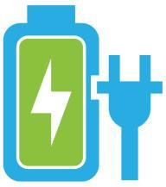
Away From School
All students are required to take their Chromebooks or iPads home each night throughout the school year for use and charging. Students are responsible for ensuring their Chromebooks or iPads are fully charged each day when they return to school. When fully charged, the Chromebook’s and iPad’s batteries should last throughout the school day.

Password Protection
Students should never share their passwords with anyone other than their
parents/guardians. This practice will help keep students’ information secure. If your password is compromised, please notify the student’s teacher.

Sound
The Chromebook’s or iPad’s speaker must always be muted during school hours unless permission is obtained from the teacher. In the classroom, Chromebook and iPad headphone use is at the teacher’s discretion.

Chromebook and iPad Web Cams
Chromebooks and iPads are equipped with a web camera. This camera offers students the opportunity to develop new communication, collaboration and creative skills. Webcams are to be used for educational purposes only and at the direction of a teacher. Some examples include:
  - Recording videos or taking pictures to include in a class project
  - Recording a student giving a speech and playing it back for rehearsal and improvement

Extensions & Add-ons
Students are responsible for any extensions, add-ons, or apps they choose to install on their Chromebooks and iPads and all such add-ons must be selected for specific educational purposes. Extensions, add-ons, or apps that are deemed inappropriate, or which cause the Chromebook or iPad to not function properly, may be removed by SSD and could result in disciplinary action.
SSD Chromebooks and iPads are not intended to be used for non-educational games and entertainment and students should not download apps or content onto their Chromebooks or iPads— or to their Google Drives — that their teachers would not consider to be “educational.”

Non-curricular Use (movies, music, social networking, gaming)
If non-instructional game apps are installed, they must be approved by the school’s administration or technology staff. The content of movies, music, social networking and games must be school and age appropriate.

Printing
If students choose to print schoolwork at home or at school, they can sign into their SSD Google account from any computer that is connected to a printer and print from that computer.

Internet Connectivity

Connecting at School
SSD Chromebooks and iPads are set to automatically connect to the SSD network when the device is turned on. If this does not happen automatically, restarting the Chromebook or iPad is the simplest way to troubleshoot the problem.

Connecting Away from School
Students can connect to non-SSD wireless networks on their Chromebooks or iPads. This will allow students to use the device effectively at home and away from school.
To see the available wireless networks on Chromebooks, click on the Wi-Fi symbol located at the bottom right corner of the Chromebook’s screen and then click to join the desired network. To see the available wireless networks on iPads, click on the settings icon, then select Wi-Fi, and then click to join the desired network.

See http://SSD.info/wifimap for locations of Wi-Fi networks outside of Sheridan schools.

NOTE: SSD recommends joining only secure networks. If students are using a public Wi-Fi network, they will be more vulnerable to hackers and snoopers. Students should therefore be mindful of entering any personal information on websites when using public networks as this information can be intercepted.

Managing Chromebook and iPad Files & Saving Work
Students’ work is automatically saved while using Google Drive. Students can convert files from Microsoft product formats (Word, Excel, PowerPoint, etc.) by uploading the files to their Google Drives. Once loaded into Google Drive, the Microsoft product created documents will automatically be converted into Google product formatting.

Google Drive allows students’ work to be shared with their teachers and their classmates. Students can create documents, spreadsheets, drawings, photos, presentations and even videos using Google’s applications. Each student-created assignment can be shared with a teacher prior to its due date.
Teachers can then see the student’s work on their own computers to review it, grade it, and supply written responses back to the student.

Students may save documents to their Google Drives or to an external memory device, such as a flash drive. Saving documents to Google Drive will make the files accessible from any computer with internet access. It is the responsibility of each student to maintain the integrity of their files and to keep proper backups.

Students may add appropriate music, photos, videos as well as other documents and media to their Google Drives. Personalized media must follow the SSD Acceptable Use Policy to ensure copyright laws are followed. All such media files are subject to inspection by SSD staff.

Gmail for Students
All students are issued an SSD Google Gmail email account. Gmail allows students to safely and effectively communicate and collaborate with Sheridan staff and classmates.

SSD Gmail Guidelines
  - SSD Gmail should be used for educational purposes only.
  - All SSD Gmail messages and their contents are the property of SSD.
  - SSD Gmail should only be used by the authorized owner of the account.

Examples of Unacceptable SSD Gmail Use:
  - Non-education related forwards (e.g. jokes, chain letters, images.)
  - Harassment, profanity, obscenity, racist terms.
  - Cyber-bullying, hate mail, discriminatory remarks.
  - Email for individual profit or gain, advertisement, or political activities.

If used improperly, students’ SSD Gmail accounts may be revoked at any time by school or district staff. Improper use may also lead to disciplinary action

Software on Chromebooks and iPads

Originally Installed Software
All Chromebooks and iPads are supplied with the latest version of the Google Chrome Operating System (OS), along with other applications potentially useful in an educational environment. SSD will install software updates when the Chromebook is shut down and restarted as needed. The software originally installed on the Chromebook must always remain on the Chromebook in usable condition and be easily accessible.

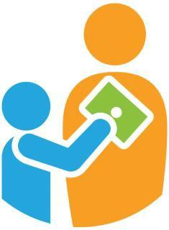
Upgraded versions of SSD licensed software and applications are periodically released for use on students’ Chromebooks and iPads. At these times, students may be required to check in their Chromebooks and iPads at their schools for updates and syncing.

Inspection
Students may be required to provide their Chromebook, iPad, and accessories for inspection by SSD school or district staff at any time. If technical difficulties occur, inappropriate software is downloaded, or apps are discovered that are suspected of harming the computer’s performance, the Chromebook’s or iPad’s system may be wiped clean and returned to its original settings. SSD does not accept responsibility for the loss of any software or documents deleted due to such reformatting and/or re-imaging processes.

Reminder: Discovery of inappropriate student Chromebook or iPad use, or inappropriate content found on a student’s Chromebook or iPad, may subject the student to disciplinary action.

Chromebook and iPad Device Troubleshooting and Help Resources
Occasionally, unexpected problems do occur with Chromebooks that are not the fault of the user
(computer crashes, software errors, etc.) The school’s technology support personnel will assist students with fixing these issues at no cost to the student.

Recommended Chromebook Troubleshooting Procedures:
- Student tries to fix the problem.
  - Always try restarting the Chromebook or iPad as the first step in troubleshooting.
  - If appropriate, student may ask a classmate for help.
  - Student may ask a teacher, if the teacher is available.
  - Reminder: Students should not spend too much time troubleshooting their Chromebooks or iPads during class and risk missing important instruction. If the student is unable to resolve the problem, the student should contact the teacher for assistance.
- The teacher or school’s technology support personnel will try to fix the problem. Otherwise, the technology support personnel will issue a replacement Chromebook or iPad to the student. At that time a ticket will be placed to the district technology support team to repair the device.
- Before turning over their Chromebooks for repair and receiving a replacement device, students should verify that all their schoolwork has been saved to their Google Drive accounts.

Restoring the OS
If technical difficulties occur, the Chromebook or iPad may be restored to its factory settings. All student-created files stored on external storage devices or Google Drive will still be intact after the operating system is restored. And if the Chromebook or iPad cannot be repaired, students will be able to access their saved Google Drive files from their replacement Chromebooks or iPads.

Login Help
For forgotten or lost usernames or passwords needed to login, go to Community Technology Support. Students can locate their student identification number within Infinite Campus or ask their teacher for help.

Copyright & Plagiarism
Students are expected to follow all U.S. copyright laws and should remember that these laws do apply to the internet. When students copy text, pictures, videos or sound clips from a website, they must cite the sources and put each citation’s text in quotation marks. Copying and pasting from online sources is easy, so it’s important that students be sure they give their sources the proper credit, otherwise, it’s considered plagiarism. And plagiarism is theft.

Internet and Social Media
Students and parents are responsible for their awareness and understanding of SSD district policies regarding students’ use of the internet and Social Media.

Internet
The SSD Internet Acceptable Use Policy can be found here.

The internet is a vital tool for education and SSD provides internet connectivity to all schools. Use of the internet requires that both students and staff follow certain rules. For example, accessing the internet for illegal, obscene or inappropriate purposes is prohibited. SSD filters internet content to prevent users from accessing illegal, obscene and inappropriate materials.

All accessed internet content can be investigated by SSD staff and should not be considered private. Students who violate the SSD internet use policy can lose their internet access and may face disciplinary action.

Social Media
The SSD Social Media Policy can be found here.

Social media, such as sites like Facebook, Google+ and Twitter, have important educational uses and can be powerful communication tools. If students and teachers are aware of the challenges and behave politely and professionally in these environments, these sites can and should be used in schools. Students who violate the SSD Social Media policy can lose their access to social media sites and may face disciplinary actions. Students should feel comfortable reporting to a school staff member if the students feel they are being harassed or bullied by a peer through social media.

Digital Citizenship
Digital Citizenship refers to the rights & responsibilities of participating in today’s global society via the internet. Elements of digital citizenship include digital communication, online etiquette (or “Netiquette”)
and digital ethics. The practice of digital citizenship entails navigating the digital world safely, responsibly, and ethically.

Practicing good digital citizenship will help create a positive school culture that supports safe and responsible technology use.

Guidelines for practicing good digital citizenship:
  - A good rule of thumb for posting on the internet is: Don’t post anything you wouldn’t want your grandmother to see.
  - Use social networking sites cautiously and appropriately.
  - Online actions have real-life consequences. If you wouldn’t do it in real life, don’t do it online.
  - Be mindful of the trail of content (postings, etc.) that you leave on the internet. Once it’s posted, you can never take it back.
  - Your future employers, friends and partners can and probably will, trace the cyber-trail you leave on the internet.
  - Keep your browsing history appropriate. Your internet history can be seen by SSD staff, even if it’s deleted.
  - SSD has a filter to prevent all users from accessing inappropriate websites when on the SSD network. However, if you accidentally stumble upon an inappropriate website, quickly exit the site, close your computer’s lid, and tell your teacher. Do not show or discuss what happened with your classmates.
  - Students are expected to notify a staff member immediately if they come across information, images, or messages that are inappropriate, dangerous, threatening, or make them feel uncomfortable.

Cyber-Bullying
Online cruelty, also referred to as cyber-bullying, takes place whenever someone uses digital media tools such as the internet to deliberately upset or harass someone else, often repeatedly. While spreading rumors and bullying is nothing new, online tools can magnify the hurt, humiliation, and social drama in a very public way.

Cyber-bullies post rumors, cruel comments or images online. The effects of cyber-bullying on individuals can lead to low self-esteem, depression, or even thoughts of violence or suicide. It’s therefore very important for parents/guardians, teachers and students alike to learn how to prevent cyber-bullying and stop it in its tracks.

Tips for preventing cyber-bullying
  - Avoid gossip.
  - Never post or email threatening, mean or embarrassing content.
  - Ignore abusive messages — don’t react at all. Cyber-bullies thrive on getting responses from their targets.
  - Get help! Don’t try to cope with cyber-bullying alone.
  - Be an Upstander (rather than just a Bystander). If you know of someone who is cyber-bullying, don’t stay silent — speak up.

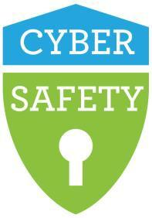
Internet Safety
Internet safety has become a fundamental topic in our digital world and includes the need for knowing about one’s internet privacy and how one’s behaviors can support healthy online interactions. The internet offers an amazing way to collaborate with others worldwide, however it is also important to distinguish between inappropriate contact and positive connections.

Internet Privacy & Security
  - Never give anyone except your parent/guardian your SSD network password or Google account information.
  - Never give out personal information, even seemingly innocent and unimportant info.
  - Use Google Drive for file sharing. There are many other file-sharing sites on the internet that can cause serious problems related to copyright infringement, spyware, and viruses.

Internet Phishing and Scams
Phishing is the slang term for using email to get people to divulge their personal information so it can be used to steal their identity. Here are some tips to avoid phishing and scams:

  - Don’t click on unfamiliar links; especially links in junk email or “spam” email.
  - Don’t reply to suspicious, junk or spam emails.
  - Don’t click on banner/pop-up ads. Clicking on them places a “cookie” on your Chromebook, allowing websites to track your movements — and these can often lead to phishing scams.
  - Don’t make online purchases without parent/guardian permission and supervision. Make sure the website is secure (it should have https: in its web address) before entering any credit card information.
  - Some websites ask you to give personal information to qualify to win a prize. Don’t be fooled! These are scams.
  - SSD will never send you an email asking for your personal information, credit card information or login information. If you receive an email asking for such information, delete it without responding — it is fraudulent and spam.

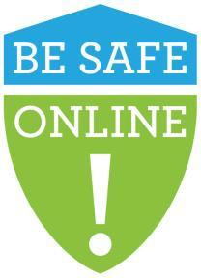
Internet Personal Safety
  - Don’t make plans online with anyone you don’t know in person.
  - Be extremely careful sharing personal information with anyone online.
  - Stick to your values when communicating with someone online.
  - Keep your parent/guardian informed about what you’re doing online so they know they can trust you.

Internet Safety Resources
- commonsensemedia.org — Education and advocacy to promote safe technology and age appropriate media
- safe2tell.org — Anonymously report anything that concerns or threatens you, your friends, your family or your community
- netsmartz.org — A program of the National Center for Missing and Exploited Children
- fosi.org — The Family Online Safety Institute

Parent/Guardian Guidance
SSD makes every effort to equip parents/guardians with the necessary tools and information to ensure their students’ safe use of the Chromebooks and iPads in the home. SSD has adopted a K-12 digital citizenship curriculum through Common Sense Media to train students in using technology tools appropriately, which is an important life skill. There are several areas where parents/guardians can support their students, and these are outlined below.

Encourage Healthy Digital Citizenship
- Monitor your students’ activity on social networking sites to ensure none of their private data is posted online, and to catch any symptoms of cyber-bullying.
- Cyber-bullying is a real thing, so please help your students avoid and prevent this despicable act.
- Set and enforce rules (e.g., time limits, behavior, purchases) for your students’ internet use.
- Know your students’ online friends.
- Be a good digital role model for your students. Demonstrate the same online behavior you expect them to use.
- Help your students understand that digital communication may not always be the best way to interact with others. Depending on the situation or the topic, face-to-face discussions or phone calls may be better options.

Monitor Student Use
The parent/guardian must agree to monitor their students’ internet use at home and away from school. The best way to keep students safe and on-task while online is to have a parent/guardian present and involved.

Suggestions
- Investigate and apply the parental controls available through your internet service provider and/or your home’s wireless router.
- Know your students’ usernames and passwords for their devices and SSD Google accounts.
- Develop a set of rules and expectations for your students’ Chromebook and iPad use at home. Set limits on the amount of time your students use technology — to help prevent physical harm due to extended and concentrated use, and to help your students to not become over- dependent on technology.
- Only allow your students’ Chromebook or iPad use in common rooms of the home (e.g., living room or kitchen) and not in students’ bedrooms.
- Get to know the websites your students access and use.
- Demonstrate a genuine interest in what your students are doing online. Frequently ask questions and request them to show you their work.

Student and Parent/Guardian Agreement for Use of Sheridan Chromebooks & iPads
This agreement is between Sheridan School District, in the city and county of Arapahoe, in the state of Colorado and:

Student Name Student Number

Parent Name School Name

As part of the 1:1 program and to give students access to online resources both in class and at home, students at Sheridan schools are assigned a district-owned Chromebook or iPad. It is intended that the student will carry this Chromebook or iPad with him/her for use at school and at home.

In consideration of the use of the Chromebook or iPad at home, parents and students agree that:
- The student will use the tool according to instructors’ guidance while outside of school.
- Parent acknowledges that while the District makes every effort to ensure security of the device, students may be able to access unsecured and unfiltered networks outside of the control of Sheridan School District 2. Responsible use of network resources is the sole responsibility of the student and parent/guardian.
- The parent and student will be personally responsible for any intentional or unintentional damage to or loss of the computing device while in the student’s care - on or off school property (see fee table below and the Sheridan 1:1 Handbook for details)

Sheridan 1:1 Damage or Loss
 | Damage |  | Loss
 | Chromebook | iPad | Chromebook | iPad | Hot Spot | Charger or Case
Incidents | $25 | $30 | $250 | $350 | $50 | $20

- The parent and student will return the device upon request in the same condition as it was received, considering normal wear and use.
- The parent and student have read the Sheridan 1:1 Handbook and will care for the Chromebook or iPad as described therein.
- Device is property of Sheridan School District 2 as is any installed software. As such, the district can monitor its use remotely and any violations of Sheridan School District’s policy can result in discipline in line with district policy.
- Devices may be erased as part of maintenance or repair. Backup of student-owned data is solely the responsibility of the student and neither the school nor the district is responsible for loss of stored files, music, video or software.
- Students will keep the device clean and in proper working condition. Students will notify a school representative immediately if the device does not work as expected or shows unusual wear.
- Any text, imagery, or audio that is illegal according to local, state, or federal law (e.g., threats, hate speech, obscene or sexual images or text) will be immediately reported to the appropriate law enforcement agency.

It is understood that the intentional failure to return the computing device to the school under some circumstances may constitute theft of district property. Any theft of district property, including the reported sale or transfer of the device for profit will be reported to the district attorney for prosecution. This agreement ends on the last day of the present school year, upon the student’s withdrawal from current school, or upon the request of the school principal or other school representative, whichever occurs first and when the device is returned in good working order or replacement fees paid.

Student Signature _________________________________________________ Date _________________

Parent/Guardian Signature ___________________________________________ Date _______________________

Sheridan1:1 Program Pledge

I agree to respect myself & others:
- I will demonstrate respect for myself and for others when posting information and images online, including personal information about my life, experiences, or relationships.
- I will not use electronic mediums to bully, harass or stalk other people.
- I will not visit sites that are degrading, pornographic, racist or inappropriate.
- I agree to disagree with others online in a respectful manner.
- I will select online names that are appropriate and inoffensive to others.
_____________ _______
(parent/guardian) (student)
I agree to not plagiarize others’ work and to obey all U.S. Copyright laws:
- I will suitably cite any and all use of websites, books, media, etc.
- I will use and abide by U.S. Copyright Fair Use rules.
- I will use free and open-source alternatives rather than pirating software and music.
- I will purchase my music and media, and refrain from distributing these in a manner that violates their licenses.
________________ ________
(parent/guardian) (student)
I agree to protect myself & others:
- I will not publish my personal contact details or a schedule of my activities.
- I will protect my passwords, accounts and resources.
- I will report any attacks or inappropriate online behavior directed at me.
- I will protect others by reporting abuse and not responding to or forwarding inappropriate materials or communications.
- I understand that my use of technology at school or elsewhere is not private.
- I understand that the SSD may monitor my use of the Chromebook or iPad and any files or products related to my use (whether they are current or deleted).
- I will remember that I need to balance technology use with other activities.
- I have read and will follow the policies outlined in the Sheridan 1:1 Program Handbook and the SSD Acceptable Use Policy while at school as well as away from school.
________________ ________
(parent/guardian) (student)

